[Homepage](https://medium.com/)

[freeCodeCamp.org](https://medium.freecodecamp.org/?source=logo-lo_bSG8Hso4I69H---336d898217ee)

Follow

[Sign in](https://medium.com/m/signin?redirect=https%3A%2F%2Fmedium.freecodecamp.org%2Fhow-to-get-https-working-on-your-local-development-environment-in-5-minutes-7af615770eec&source=--------------------------nav_reg&operation=login)[Get started](https://medium.com/m/signin?redirect=https%3A%2F%2Fmedium.freecodecamp.org%2Fhow-to-get-https-working-on-your-local-development-environment-in-5-minutes-7af615770eec&source=--------------------------nav_reg&operation=register)

* [HOME](https://medium.freecodecamp.org/)
* [DEV](https://medium.freecodecamp.org/tagged/web-development)
* [LEARN TO CODE FOR FREE](https://www.freecodecamp.com/?ref=mn)

[Go to the profile of Daksh Shah](https://medium.freecodecamp.org/@dakshshah?source=post_header_lockup)

[Daksh Shah](https://medium.freecodecamp.org/@dakshshah?source=post_header_lockup)Follow

Making the web a better place, one line at a time · Self-taught Engineer, Learner, Bibliophile · Building cool stuff with JavaScript at @GoPedalIndia

Jan 19

**How to get HTTPS working on your local development environment in 5 minutes**

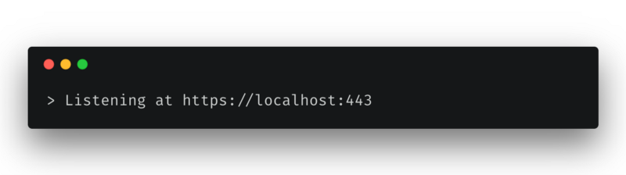

Almost any website you visit today is protected by HTTPS. If yours isn’t yet, [it should be](https://developers.google.com/web/fundamentals/security/encrypt-in-transit/why-https). Securing your server with HTTPS also means that you can’t send requests to this server from one that isn’t protected by HTTPS. This poses a problem for developers who use a local development environment because all of them run on http://localhost out-of-the-box.

At the startup I’m a part of, we decided to secure our AWS Elastic Load Balancer endpoints with HTTPS as part of a move to enhance security. I ran into a situation where my local development environment’s requests to the server started getting rejected.

A quick Google search later, I found several articles like [this](https://devcenter.heroku.com/articles/ssl-certificate-self), [this](https://www.kevinleary.net/self-signed-trusted-certificates-node-js-express-js/) or [this one](https://blog.praveen.science/securing-your-localhost/)with detailed instructions on how I could implement HTTPS on localhost. None of these instructions seemed to work even after I followed them religiously. Chrome always threw a NET::ERR_CERT_COMMON_NAME_INVALID error at me.

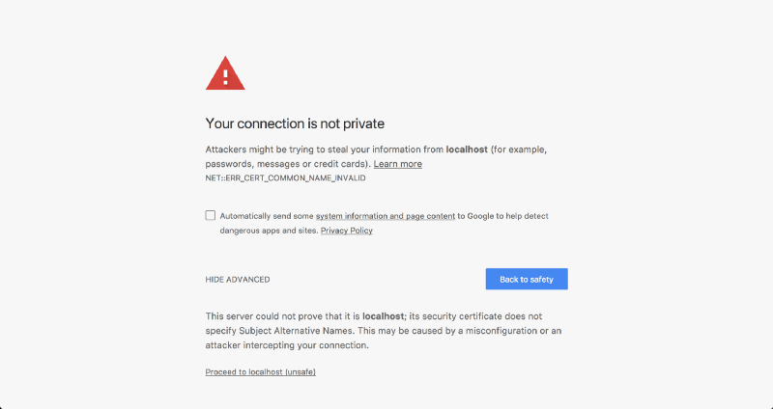

**The problem**

All the detailed instructions I had found were correct for the time they were written. Not anymore.

After a ton of Googling, I discovered that the reason for my local certificate getting rejected was that [Chrome had deprecated support for commonName matching in certificates](https://groups.google.com/a/chromium.org/forum/m/#!topic/security-dev/IGT2fLJrAeo), in effect, requiring a subjectAltName since January 2017.

**The solution**

We’ll be using [OpenSSL](https://www.openssl.org/) to generate all of our certificates.

**Step 1: Root SSL certificate**

The first step is to create a Root Secure Sockets Layer (SSL) certificate. This root certificate can then be used to sign any number of certificates you might generate for individual domains. If you aren’t familiar with the SSL ecosystem, this [article from DNSimple](https://support.dnsimple.com/articles/what-is-ssl-root-certificate/) does a good job of introducing Root SSL certificates.

Generate a RSA-2048 key and save it to a file rootCA.key. This file will be used as the key to generate the Root SSL certificate. You will be prompted for a pass phrase which you’ll need to enter each time you use this particular key to generate a certificate.

openssl genrsa -des3 -out rootCA.key 2048

You can use the key you generated to create a new Root SSL certificate. Save it to a file namedrootCA.pem. This certificate will have a validity of 1,024 days. Feel free to change it to any number of days you want. You’ll also be prompted for other optional information.

openssl req -x509 -new -nodes -key rootCA.key -sha256 -days 1024 -out rootCA.pem

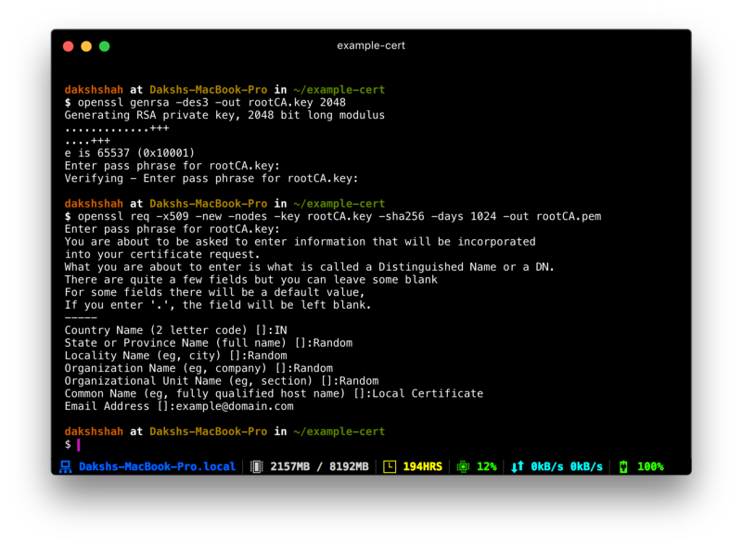

**Step 2: Trust the root SSL certificate**

Before you can use the newly created Root SSL certificate to start issuing domain certificates, there’s one more step. You need to to tell your Mac to trust your root certificate so all individual certificates issued by it are also trusted.

Open Keychain Access on your Mac and go to the Certificates category in your System keychain. Once there, import the rootCA.pem using File > Import Items. Double click the imported certificate and change the “When using this certificate:” dropdown to **Always Trust** in the Trust section.

Your certificate should look something like this inside Keychain Access if you’ve correctly followed the instructions till now.

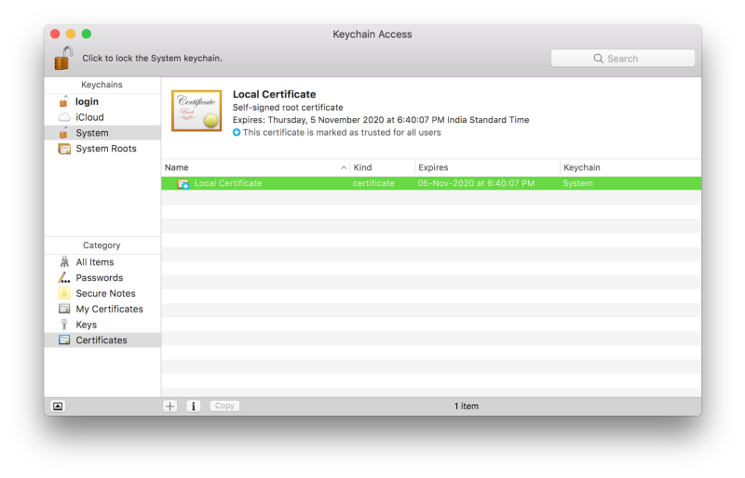

**Step 2: Domain SSL certificate**

The root SSL certificate can now be used to issue a certificate specifically for your local development environment located at localhost.

Create a new OpenSSL configuration file server.csr.cnf so you can import these settings when creating a certificate instead of entering them on the command line.

[req]  
default_bits = 2048  
prompt = no  
default_md = sha256  
distinguished_name = dn  
  
[dn]  
C=US  
ST=RandomState  
L=RandomCity  
O=RandomOrganization  
OU=RandomOrganizationUnit  
emailAddress=hello@example.com  
CN = localhost

Create a v3.ext file in order to create a [X509 v3 certificate](https://en.wikipedia.org/wiki/X.509). Notice how we’re specifying subjectAltName here.

authorityKeyIdentifier=keyid,issuer  
basicConstraints=CA:FALSE  
keyUsage = digitalSignature, nonRepudiation, keyEncipherment, dataEncipherment  
subjectAltName = @alt_names  
  
[alt_names]  
DNS.1 = localhost

Create a certificate key for localhost using the configuration settings stored in server.csr.cnf. This key is stored in server.key.

openssl req -new -sha256 -nodes -out server.csr -newkey rsa:2048 -keyout server.key -config <( cat server.csr.cnf )

A certificate signing request is issued via the root SSL certificate we created earlier to create a domain certificate for localhost. The output is a certificate file called server.crt.

openssl x509 -req -in server.csr -CA rootCA.pem -CAkey rootCA.key -CAcreateserial -out server.crt -days 500 -sha256 -extfile v3.ext

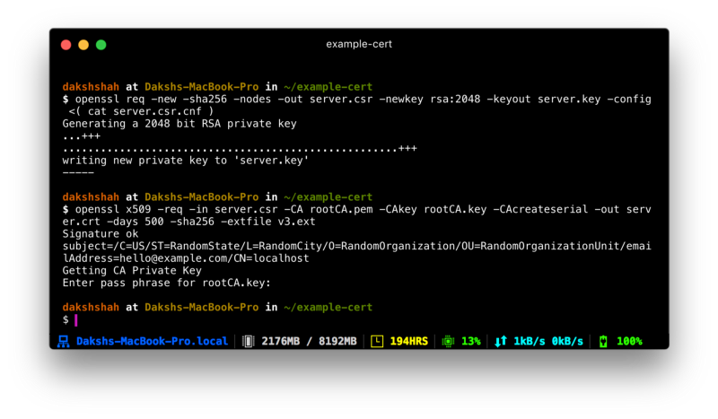

**Use your new SSL certificate**

You’re now ready to secure your localhost with HTTPS. Move the server.key and server.crt files to an accessible location on your server and include them when starting your server.

In an Express app written in Node.js, here’s how you would do it. Make sure you do this only for your local environment. **Do not use this in production**.

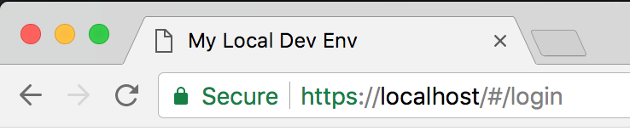

I hope you found this tutorial useful. If you’re not comfortable with running the commands given here by yourself, I’ve created a set of handy scripts you can run quickly to generate the certificates for you. More details can be found on the [GitHub repo](https://github.com/dakshshah96/local-cert-generator/).

I love helping fellow web developers. Follow me on [Twitter](https://twitter.com/daksh_shah) to let me know if you have any suggestions or feedback.

* [Https](https://medium.freecodecamp.org/tagged/https?source=post)
* [Ssl](https://medium.freecodecamp.org/tagged/ssl?source=post)
* [Development](https://medium.freecodecamp.org/tagged/development?source=post)
* [Security](https://medium.freecodecamp.org/tagged/security?source=post)
* [Tech](https://medium.freecodecamp.org/tagged/tech?source=post)

14.7K

95

• Follow

[Go to the profile of Daksh Shah](https://medium.freecodecamp.org/@dakshshah?source=footer_card)

[**Daksh Shah**](https://medium.freecodecamp.org/@dakshshah)

Making the web a better place, one line at a time · Self-taught Engineer, Learner, Bibliophile · Building cool stuff with JavaScript at [@GoPedalIndia](http://twitter.com/GoPedalIndia)

• Follow

[freeCodeCamp.org](https://medium.freecodecamp.org/?source=footer_card)

[**freeCodeCamp.org**](https://medium.freecodecamp.org/?source=footer_card)

Stories worth reading about programming and technology from our open source community.

[More from freeCodeCamp.org](https://medium.freecodecamp.org/how-i-switched-careers-and-got-a-developer-job-in-10-months-a-true-story-b8895e855a8b?source=placement_card_footer_grid---------0-41)

[How I switched careers and got a developer job in 10 months: a true story](https://medium.freecodecamp.org/how-i-switched-careers-and-got-a-developer-job-in-10-months-a-true-story-b8895e855a8b?source=placement_card_footer_grid---------0-41)

[Go to the profile of Syk Houdeib](https://medium.freecodecamp.org/@Syknapse)

[Syk Houdeib](https://medium.freecodecamp.org/@Syknapse?source=placement_card_footer_grid---------0-41)

9.1K

[More from freeCodeCamp.org](https://medium.freecodecamp.org/what-is-a-quantum-computer-explained-with-a-simple-example-b8f602035365?source=placement_card_footer_grid---------1-41)

[What is a quantum computer? Explained with a simple example.](https://medium.freecodecamp.org/what-is-a-quantum-computer-explained-with-a-simple-example-b8f602035365?source=placement_card_footer_grid---------1-41)

[Go to the profile of YK Sugi](https://medium.freecodecamp.org/@ykdojo)

[YK Sugi](https://medium.freecodecamp.org/@ykdojo?source=placement_card_footer_grid---------1-41)

4K

[More from freeCodeCamp.org](https://medium.freecodecamp.org/these-tools-will-help-you-write-clean-code-da4b5401f68e?source=placement_card_footer_grid---------2-41)

[These tools will help you write clean code](https://medium.freecodecamp.org/these-tools-will-help-you-write-clean-code-da4b5401f68e?source=placement_card_footer_grid---------2-41)

[Go to the profile of Adeel Imran](https://medium.freecodecamp.org/@adeelimranr)

[Adeel Imran](https://medium.freecodecamp.org/@adeelimranr?source=placement_card_footer_grid---------2-41)

2.5K

**Responses**

Write a response…

Applause from [Daksh Shah](https://medium.com/@dakshshah) (author)

[Go to the profile of Andrew Erickson](https://medium.com/@andrewbiang)

[Andrew Erickson](https://medium.com/@andrewbiang?source=responses---------0-31--------------------)

[Jan 20](https://medium.com/@andrewbiang/after-a-week-of-going-through-tutorial-after-tutorial-medium-sent-this-article-to-me-in-an-email-9cc56fb1fbe5?source=responses---------0-31--------------------)

[After a week of going through tutorial after tutorial, Medium sent this article to me in an email. After following your article and getting SSL to work (for Chrome specifically) on localhost, my first impulse was to Slack my friends “KISS THE BABY! IT WORKED!”](https://medium.com/@andrewbiang/after-a-week-of-going-through-tutorial-after-tutorial-medium-sent-this-article-to-me-in-an-email-9cc56fb1fbe5?source=responses---------0-31--------------------)

[Thank you Daksh Shah for the article and you Universe / Medium for being creepy AF.](https://medium.com/@andrewbiang/after-a-week-of-going-through-tutorial-after-tutorial-medium-sent-this-article-to-me-in-an-email-9cc56fb1fbe5?source=responses---------0-31--------------------)

87

Applause from [Daksh Shah](https://medium.com/@dakshshah) (author)

[Go to the profile of chetan vashistth](https://medium.com/@chetanhere)

[chetan vashistth](https://medium.com/@chetanhere?source=responses---------1-31--------------------)

[Jan 21](https://medium.com/@chetanhere/thanks-a-lot-daksh-for-writing-this-highly-valuable-piece-98a366892d04?source=responses---------1-31--------------------)

[Thanks a lot Daksh for writing this highly valuable piece. I recommend all web developers to bookmark this, you are going to need this information very soon.](https://medium.com/@chetanhere/thanks-a-lot-daksh-for-writing-this-highly-valuable-piece-98a366892d04?source=responses---------1-31--------------------)

12

Applause from [Daksh Shah](https://medium.com/@dakshshah) (author)

[[Go to the profile of Roy Huff ♛](https://medium.com/@EvervilleFans)](https://medium.com/@EvervilleFans)

[Roy Huff ♛](https://medium.com/@EvervilleFans?source=responses---------2-31--------------------)

[Jan 21](https://medium.com/@EvervilleFans/great-trick-2982a75114ec?source=responses---------2-31--------------------)

[working](https://medium.freecodecamp.org/how-to-get-https-working-on-your-local-development-environment-in-5-minutes-7af615770eec?source=responses---------2-31--------------------" \l "a856)

[Great trick.](https://medium.com/@EvervilleFans/great-trick-2982a75114ec?source=responses---------2-31--------------------)

15

Conversation with [Daksh Shah](https://medium.com/@dakshshah).

[Go to the profile of Atakan Yenel](https://medium.com/@atakanyenel)

[Atakan Yenel](https://medium.com/@atakanyenel?source=responses---------3---------------------)

[Jan 19](https://medium.com/@atakanyenel/this-will-be-super-unrelated-to-the-subject-but-what-is-your-terminal-shell-it-looks-very-cool-d82ef9ea3c6f?source=responses---------3---------------------)

[This will be super unrelated to the subject but what is your terminal shell ? It looks very cool !!](https://medium.com/@atakanyenel/this-will-be-super-unrelated-to-the-subject-but-what-is-your-terminal-shell-it-looks-very-cool-d82ef9ea3c6f?source=responses---------3---------------------)

38

[3 responses](https://medium.com/@atakanyenel/this-will-be-super-unrelated-to-the-subject-but-what-is-your-terminal-shell-it-looks-very-cool-d82ef9ea3c6f?source=responses---------3---------------------#--responses)

[Go to the profile of Daksh Shah](https://medium.com/@dakshshah)

[Daksh Shah](https://medium.com/@dakshshah?source=responses---------3---------------------)

[Jan 21](https://medium.com/@dakshshah/not-a-problem-ataken-77c682c9e152?source=responses---------3---------------------)

[Not a problem Ataken! I’m using Hyper as my terminal. The status bar you see at the bottom is the HyperLine plugin.](https://medium.com/@dakshshah/not-a-problem-ataken-77c682c9e152?source=responses---------3---------------------)

24

Conversation with [Daksh Shah](https://medium.com/@dakshshah).

[Go to the profile of Šime Vidas](https://medium.com/@simevidas)

[Šime Vidas](https://medium.com/@simevidas?source=responses---------4---------------------)

[Jan 20](https://medium.com/@simevidas/could-you-elaborate-on-this-516a8cc215db?source=responses---------4---------------------)

[At the startup I’m a part of, we decided to secure our AWS Elastic Load Balancer endpoints with HTTPS as part of a move to enhance security. I ran into a situation where my local dev...](https://medium.freecodecamp.org/how-to-get-https-working-on-your-local-development-environment-in-5-minutes-7af615770eec" \l "32a8)

[Could you elaborate on this? I’m trying to understand this scenario. So, you’re running a web server locally, and that server is making requests to another web server on the Internet, and those requests are then being rejected? Does this mean that after enabling HTTPS on AWS, all non-secure requests are rejected?](https://medium.com/@simevidas/could-you-elaborate-on-this-516a8cc215db?source=responses---------4---------------------)

3

[1 response](https://medium.com/@simevidas/could-you-elaborate-on-this-516a8cc215db?source=responses---------4---------------------#--responses)

[Go to the profile of Daksh Shah](https://medium.com/@dakshshah)

[Daksh Shah](https://medium.com/@dakshshah?source=responses---------4---------------------)

[Jan 22](https://medium.com/@dakshshah/yes-thats-exactly-what-happened-a9c90107dcb5?source=responses---------4---------------------)

[Yes, that’s exactly what happened. Since the endpoint changed from http://aws.example.com to https://aws.example.com, all requests from http://localhost started getting rejected with an “Unauthorized” error. At least that’s what happened in our case.](https://medium.com/@dakshshah/yes-thats-exactly-what-happened-a9c90107dcb5?source=responses---------4---------------------)

11

[1 response](https://medium.com/@dakshshah/yes-thats-exactly-what-happened-a9c90107dcb5?source=responses---------4---------------------#--responses)

Show all responses

* 14.7K

[freeCodeCamp.org](https://medium.freecodecamp.org/)

Never miss a story from**freeCodeCamp.org**, when you sign up for Medium. [Learn more](https://medium.com/@Medium/personalize-your-medium-experience-with-users-publications-tags-26a41ab1ee0c#.hx4zuv3mg)